To all members of the Knockholt Parish Council:

You are hereby summoned to attend the Parish Council Meeting to be held in the Village Centre on Monday 6th October 2025 at 645p.m. to discuss the following business.

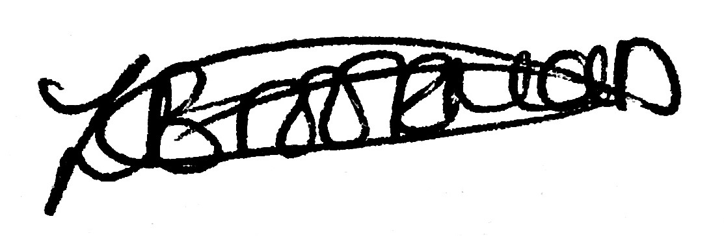

Zoe Brookman Clerk to the Council

THE FIRST TEN MINUTES OF THIS MEETING ARE AVAILABLE FOR THE PUBLIC TO EXPRESS A VIEW OR ASK A QUESTION ON RELEVANT MATTERS ON THE FOLLOWING AGENDA. THE PUBLIC ARE WELCOME TO STAY AND OBSERVE THE REST OF THE MEETING.

AGENDA
- Apologies and reasons for absence.
- Declarations of interest on items on the agenda.
- Dispensations.
- Minutes of the previous meeting of Monday 1st September to be agreed and signed as a true record. Circulated to all Councillors.
5. Clerk’s Report.
6. RFO’s report and Accounts for payment.

- Payments made by agreement since the last meeting.
- To resolve to approve payment list with supporting documentation.
- To note monies received.
- To note bank reconciliation to 30th September 2025.

7. Committee Reports.
7.1 Amenities
a. Hunters walk.
b. Land at Letts Green.
c. BT Fibre.
d. Chime Farm Lamppost.
e. KATS storage.
f. Manure Dumping- Rushmore Hill.
g. Hedge Maintenance.

h. Review of standing orders policies and procedures.
i. Knockstock
j. Hampton Cottages Trust
  - Finance
- Parish Room.
- Review of committee projects for 2025/26 budget.
- KVCC financial standing
- Conclusion of Annual Governance & Accountability Audit 2024-25 To consider the conclusion of the audit of the Annual Governance & Accountability Return (AGAR) 2024-25.

7.3 Planning and Transportation
- Update on SDC Local Plan and Fort Halstead plan.
- The Three Horseshoes.
7.4 Highways
  - Minutes of the Highways committee held on Thursday 2nd October to be agreed and signed as a true record. Circulated to all Councillors.

  - HIP update.
c. Tree Stump/Low hanging branches Pound Lane.
d. Pound Lane drainage.
  - Publicity and Media
- Minutes of the Publicity & Media committee held on Monday 22nd September 16th to be agreed and signed as a true record. Circulated to all Councillors.
- Email addresses (.gov/.org).
- Website.
  - Sports and Leisure
- Playground equipment

8. Police Report.
9. Consultations.
10. Events.
11. Information items for inclusion on the next agenda.

Date of next Parish Council meeting Monday 3rd November 2025.
Parishioners may ask brief questions after the initial close of the meeting.

